Authors' Instructions for the Preparation of

Contributions to Proceedings of the 9th International

Conference on Hydroelasticity in Marine Technology

Name, A.^{1*}, Name, B.C.² and Name, D.E.F.³

¹ Affiliation, City, Country (email@address)
² Affiliation, City, Country (email@address)
³ Institute of Marine Engineering, National Research Council, Rome, Italy (abcdef@cnr.it)

Abstract. In this paper you will find important instructions for authors of the contributions to the Proceedings using Word. English is a formal language of the papers. Manuscript should be written precisely with a proper title, names of the authors, their affiliations. The abstract should summarize the contents of the paper and should contain from 70 to 150 words. Up to five keywords should follow the abstract as shown below.

Key words: Key word 1; Key word 2; Key word 3; Key word 4; Key word 5

1. Introduction

The section title should be written with ‘Times New Roman’ fonts of 12 point size. It should be all capitals. The main description should be written with 11 point size. The paper should be written in A4 paper with the margin of the present template. There is no strict limitation to the number of pages, but it is suggested that the paper length should not exceed 10 pages.

1.1 Files to be sent

Send us both the Word and pdf file of your contribution. Please pack all your files in one of the common archives and submit them through the Conference website www.hyel2022.org.

2. Paper preparation

2.1 Equation

Equations are centered and set in a separate line with extra space above and below, and they also should be numbered for reference. The equation numbers should be consecutive within your contribution and should be written in parentheses on the right margin.
Below an example for equation is given:

$w\left(x,t\right)=w_{G}\left(t\right)+\left(x-x_{G}\right)θ\left(t\right)-h(x,t)$ (1)

2.2 Figures and Tables

Figures and tables should be numbered sequentially in the order cited in the text and legends of the figures must be placed at proper locations in the text. Figures should be numbered and should have a caption positioned under the figures, in contrast to the caption belonging to a table, which should always appear above the table. Line drawings should have a resolution of at least 800 dpi (preferably 1200 dpi). In order to ensure a reasonable quality of the reproduction of your illustrations we do not advise usage of shading. The contrast between the elements of the illustration should be as pronounced as possible.
If program screenshots are necessary, please make sure that you are happy with the print quality before you send the files.
Illustrations for the printed Proceedings should generally be black and white (halftones). If you send colored figures they will be printed in black and white, thus please make sure that they really are legible in black and white. Some colors as well as the contrast of converted colors show up very poorly when printed in black and white.

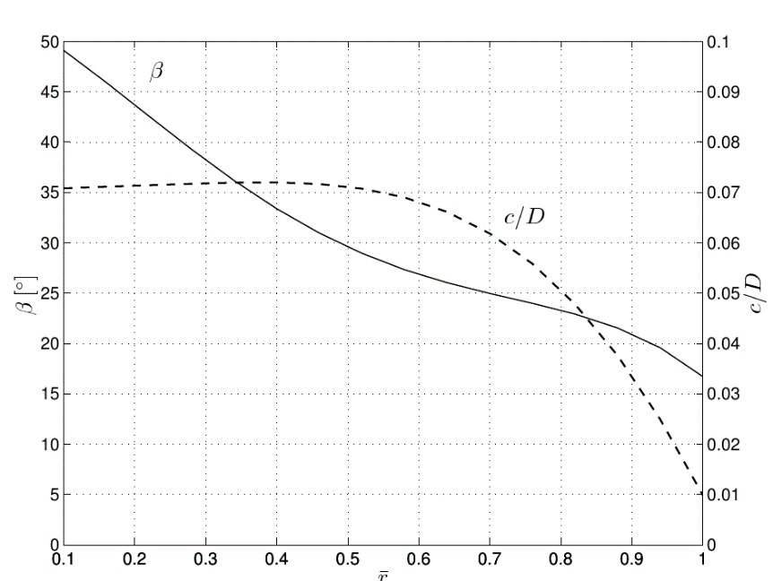
Figure 1: This example figure presents propeller geometry with β pitch angle (solid line) and c chord (dashed line) distribution along span. Sample figure with different line types can be described in caption by emphasizing the elements description in italics.
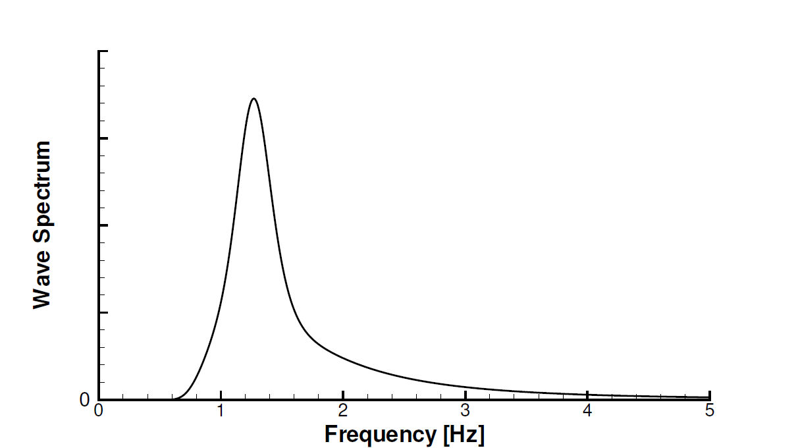
Figure 2: Alternatively, you can also include figures using Arial as character font for axis label, legend entries and so on. It is strongly suggested to keep the same character size for figures throughout your paper.

Table 1. An example table.
Name | Unit | Ship scale | Model scale
$$L_{pp}$$ | m | 128.6 | 4.280
$$B$$ | m | 18.26 | 0.609
$$T$$ | m | 3.88 | 0.129

2.3 References

References should be listed in citation order within the body of your contribution. Unpublished results and personal communications should not be included. References should be cited in the text with numbers in square brackets. Below a bibliography example can be found.

Acknowledgements

Authors may want to express their acknowledgements to people and/or funding agencies for supporting their research.

References

- R.E.D. Bishop, W.G. Price, Hydroelasticity of ships, Cambridge University Press, London, 1979.
- M.K. Ochi, and L.E. Motter, Prediction of slamming characteristics and hull responses for ship design, Transaction of Society of Naval Architects and Marine Engineers, 81:144-176, 1973.
- M. Schiffman, D.C. Spencer, The force of impact on a cone striking a water surface vertical entry, Comm. Pure Appl. Math., 4:379-417, 1951.

